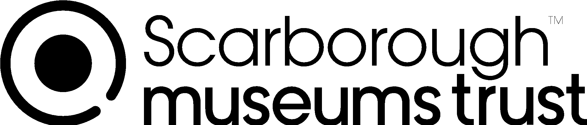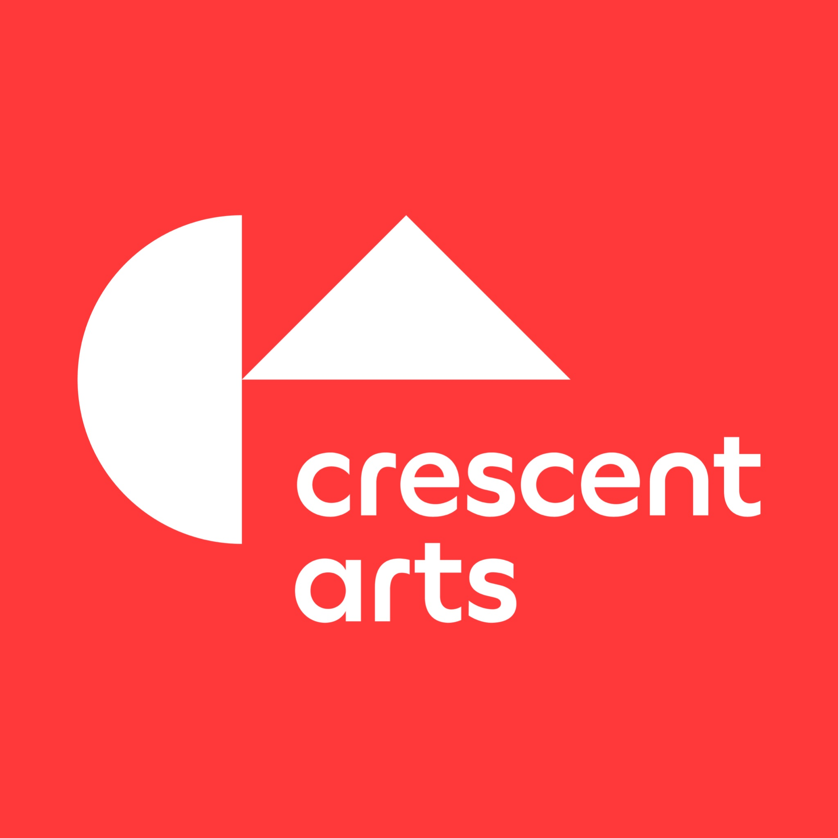

Artist/Project Lead - Cross Lane Hospital/Crescent Arts/Scarborough Museums Trust

Hello!

Crescent Arts (CA), Cross Lane Hospital (CLH) and Scarborough Museums Trust (SMT) are seeking a digitally-focused artist with experience of working in settings with people with mental health needs to undertake a co-produced creative investigation with in-patients at CLH. They will lead a project to explore how digital technology can be used to support well-being, reduce isolation and de-escalate stress. The project is part of the warm welcome CA and SMT want to extend to people with diverse minds and bodies and is a first step to help us learn how we can support specifically people who have lived experience of mental illness when they visit our venues.

Who are we?

Crescent Arts: Founded in 1979, CA is a vibrant creative hub rooted in Scarborough: responding to the need for equity and social justice by nurturing diverse artistic talent, connecting people to art and artists, making contemporary visual arts publicly accessible through meaningful participation and enjoyment, and working to address the climate crisis and support climate justice.
Link to CA website: http://www.crescentarts.co.uk

Scarborough Museums Trust: SMT manages three heritage sites - Scarborough Art Gallery, Rotunda Museum and Woodend Creative Workspace. Recently, we have been identifying the impacts we might make on our local community and society as a whole. We want to help Scarborough become connected to the world. Support the health and wellbeing of our communities and ensure everyone feels valued.
Link to SMT website: https://www.scarboroughmuseumstrust.com

Cross Lane Hospital: The Ayckbourn Unit, managed under Tees, Esk and Wear Valleys NHS Foundation Trust at Cross Lane Hospital in Scarborough, consists of two acute mental health wards: Esk Ward which is a 13 bedded female unit and Danby, a 13 bedded male unit. The Occupational Therapy (OT) team recognises the valuable role arts and culture can play in reducing psychological distress. We are committed to creating environments that encourage participation, interaction, involvement and inclusion in a non-judgemental way. We are excited to be collaborating with CA and SMT on this project as our vision is to work alongside community hubs to explore sensory and creative experiences and interventions and evaluate their use in mental health care and recovery.

What is the project?

This pilot project will see an artist/s supported by CA and SMT to work with staff and in-patients at CLH to develop in collaboration, a digitally focused project/work that can aid and think about the role of creativity in supporting the well-being of people who experience mental health conditions and creating healing environments. The project will be adaptable - thinking about process not just product - and responsive to the care needs of all involved throughout. It will incorporate action-learning and the artist will be expected to participate in on-going evaluation activities, which may include interviews and a reflective journal.

What are the proposed outputs?

- An accessible digital resource that supports creative and calming outcomes
- A methodology that can be shared amongst wider health professionals, creatives and other stakeholders through a ‘sharing’ event
- An embedded evaluation process which will require the successful artist to have regular contact with our evaluators
- A ‘next steps’ conversation which may form part of ongoing evaluation
- A mental health and art focus group which the artist will engage with

What are the potential outcomes?

As a learning opportunity for everyone, we hope to see the following outcomes:

Outcome for patients:
- Learn new digital skills
- Have access to new environments and the arts
- Reduce isolation
- Resources/tool kits for coping strategies when distressed
- Feel connected to a wider community

Outcome for Institutions:
- Make the arts more inclusive
- Support artists’ development
- Increase conversations around art and wellbeing
- Artists, participants and staff feel cared-for and supported
- Lead to future collaborations
- Work with technology and digital

Outcome for artists:
- Connected with new communities
- Feel cared for and supported
- Opportunity to test ideas
- Develop conversations around the arts and mental health to support creative personal development

This project marks the start of a new collaboration for all three organisations and first steps towards us developing activities around mental health, creativity and the arts going forward.

Who are we looking for?

The artist will need to have the following skills and interests:
- Significant experience of working in mental health settings on creative projects with people with a range of mental health needs
- Experience of using co-production methodologies with participants facing specific challenges
- A track record in developing and delivering projects with digital outcomes
- Experience of/a willingness to embed access as part of the creative process
- Confident and sensitive leadership skills
- Strong organisational and writing skills, including preparing written reports and feedback
- Experience of communicating with a wide range of stakeholders and participants
- An open-minded approach which is based on process rather than product
- A flexible and adaptable outlook rooted in warmth and humour
- Sustainable working practices that go beyond using recycled paper

What is the timeframe?

The project will start in July 2021 and end by October 2021 so the selected artist must be free to commit to travelling to Scarborough for workshops between those dates.

What is the fee?
The total commissioning fee is £4665, including fees (equivalent to 12 days work at £284.58 based on Artists’ Union England daily rates), travel expenses and production costs (these may be produced by or commissioned by the selected artist who will manage any outsourcing). The budget will be managed by the artist.

A budget is available in addition to the fee for any access costs for the artist to undertake the work.

What support would I get?
- In addition to the fee outlined above, accommodation will be arranged and provided by the project organisers.
- A mentoring session with an access-focused artist
- Independent counselling support with a qualified counsellor (up to six sessions)
- Participation in a people-centred evaluation strand that will provide a safe and non-judgemental space for the artist to share feedback

A separate budget to incorporate access provisions (such as audio description, production of social stories etc.)

What is the role of Cross Lane Hospital, Crescent Arts and SMT?

We expect the artist to work closely with all three organisations, be receptive to working collaboratively and incorporating our current methodologies. We will provide:
- Access to and specialist support with working with participants (CLH)
- Creatively supporting the development of ideas and expanding networks (CA/SMT)
- Support with project management (CA/SMT)
- Support with best practice for access and inclusion in digital/online work in the cultural sector (CA/SMT/Mentor)
- Publicising the project on our website, social media etc. (CA/SMT)

How to Apply?

Please send the following information to: dorcas.taylor@smtrust.uk.com
- Your CV and a link to your work (eg website/Instagram)
- A short statement of interest in no more than 500 words or a video or audio of no more that 5 minutes about why your skills and experience make you suitable for this role, including a brief summary of your proposed methodology
- Contact details of two professional referees
- Our equal opportunities form

We welcome applications from everyone and particularly encourage applicants who are usually under-represented in the arts.

Please let us know if there are any reasonable adjustments or access requirements you would need in order to be interviewed for the role.

If you have any queries about the content of this brief, please contact Dorcas Taylor, Curator at SMT (dorcas.taylor@smtrust.uk.com) and Martha Cattell, Curator at CA (curator@crescentarts.co.uk) who are co-leading this project.

Please submit your CV and statement of interest to: dorcas.taylor@smtrust.uk.com by Monday 14 June. We will meet with shortlisted artists (by zoom or in person, depending on availability and access needs) on Monday 21 June.

